Lexical Issues in Java:
Java programs are a collection of whitespace, identifiers, literals, comments, operators, separators, and
keywords.
Whitespace:
Java is a free-form language. This means that you do not need to follow any special indentation rules. For instance, the Example program could have been written all on one line or in any other strange way you felt like typing it, as long as there was at least one whitespace character between each token that was not already delineated by an operator or separator. In Java, whitespace includes a space, tab, newline, or form feed.
Identifiers:
Identifiers are used to name things, such as classes, variables, and methods. An identifier may be any descriptive sequence of uppercase and lowercase letters, numbers, or the underscore and dollar-sign characters. (The dollar-sign character is not intended for general use.) They must not begin with a number, lest they be confused with a numeric literal. Again, Java is case-sensitive, so VALUE is a different identifier than Value. Some examples of valid identifiers are Invalid identifier names include these: NOTE Beginning with JDK 9, the underscore cannot be used by itself as an identifier.
Literals:
A constant value in Java is created by using a literal representation of it. For example, here are some literals: Left to right, the first literal specifies an integer, the next is a floating-point value, the third is a character constant, and the last is a string. A literal can be used anywhere a value of its type is allowed.
Comments:
As mentioned, there are three types of comments defined by Java. You have already seen two: single-line and multiline. The third type is called a documentation comment. This type of comment is used to produce an HTML file that documents your program. The documentation comment begins with a /** and ends with a */.
Separators:
In Java, there are a few characters that are used as separators. The most commonly used separator in Java is the semicolon. As you have seen, it is often used to terminate statements. The separators are shown in the following table:
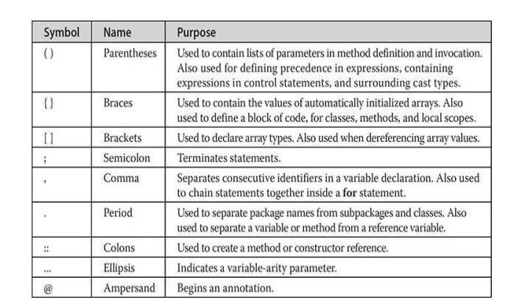

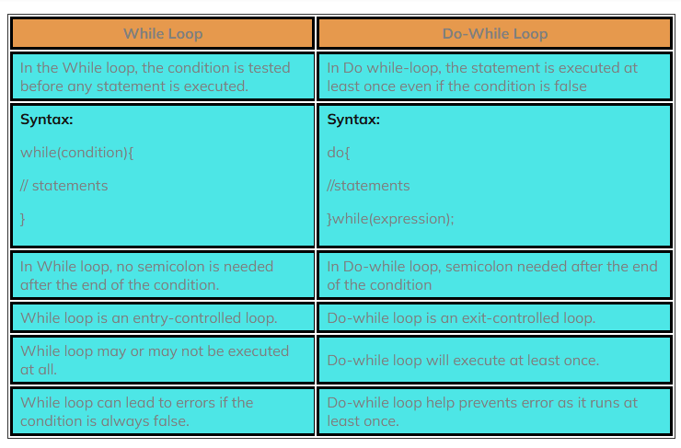

The general rules for naming variables are:
- Names can contain letters, digits, underscores, and dollar signs
- Names must begin with a letter
- Names should start with a lowercase letter, and cannot contain whitespace
- Names can also begin with $ and _
- Names are case-sensitive ("myVar" and "myvar" are different variables)
- Reserved words (like Java keywords, such as int or boolean) cannot be used as names
Rules for naming identifiers
- A valid identifier can have letters (both uppercase and lowercase letters), digits and underscores.
- The first letter of an identifier should be either a letter or an underscore.
- You cannot use keywords like int, while etc. as identifiers.
- There is no rule on how long an identifier can be. However, you may run into problems in some compilers if the identifier is longer than 31 characters.

Write a Java program to implement a linear Search Algorithm.

class LinearSearch{
public static void main(String args[]){
int array[] = {10, 20, 25, 63, 96, 57};
int key = 63,flag=0;

for (int i=0 ;i< array.length; i++)
{
if(array[i]==key)
{
flag=1;
break;
}
}
if(flag==1)
System.out.println("Element found index is :"+ i);
else
System.out.println("Element not found");

}//end of main
}//end of class

